**6: Create ReplicaSets using YAML**

**Create ReplicaSet Definition**

--- **replicaset-definition.yml**

apiVersion: apps/v1

kind: ReplicaSet

metadata:

  name: myapp2-rs # this is just a replicaset name.

spec:

  replicas: 3 # 3 Pods should exist at all times.

  selector:  # Pods label should be defined in ReplicaSet label selector

    matchLabels:

      app: myapp2

  template:

    metadata:

      name: myapp2-pod

      labels:

        app: myapp2 # Atleast 1 Pod label should match with ReplicaSet Label Selector

    spec:

      containers:

      - name: myapp2

        image: stacksimplify/kubenginx:2.0.0

        ports:

          - containerPort: 80

**Create ReplicaSet with 3 Replicas**

**# Create ReplicaSet**

--- **kubectl apply -f 02-replicaset-definition.yml**

**# List Replicasets**

--- **kubectl get rs**

**# List Pods**

--- **kubectl get pods**

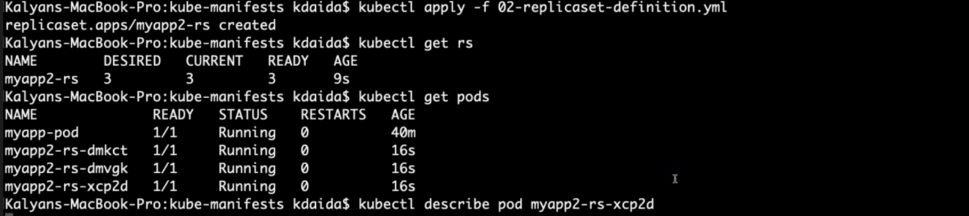

**# Describe pod**

--- **kubectl describe pod myapp2-rs-xcp2d** – to describe pod to see whether it created pod from mentioned image.

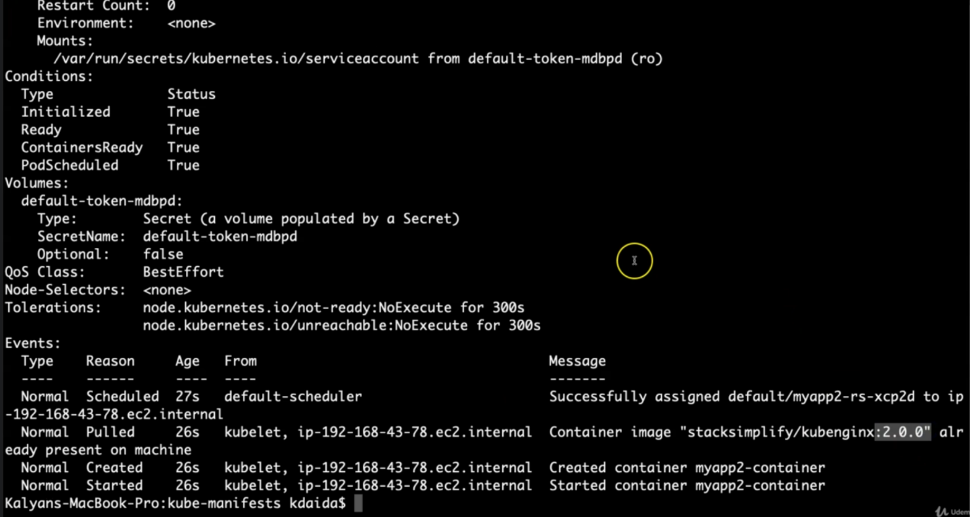

--- note – the pods are created rom mentioned image.

**# Delete Pod**

--- **kubectl delete pod <Pod-Name>**